2018-2019 UdayanCareUSA Annual Report
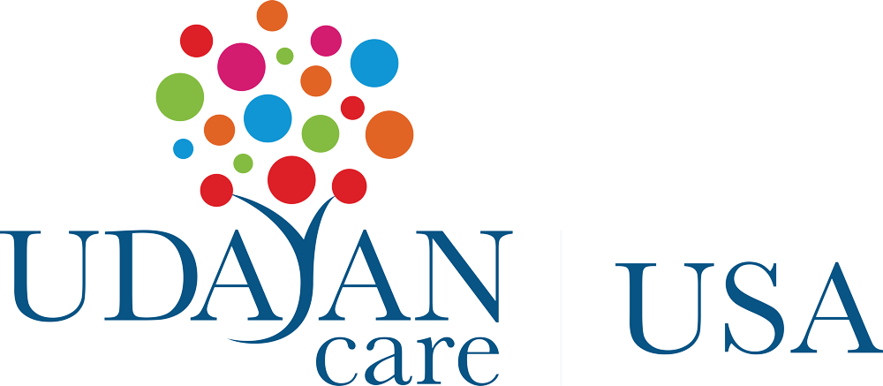
Overview
Udayan Care USA (UCUSA) was incorporated in 2009 by Udayan Care‘s international volunteers and donors, Jesse George-Nichol, Ricky Surie, and Seth Call, as well as Dr Kiran Modi, founder of Udayan Care from India. This new entity was registered to propagate Udayan Care India’s message to the US citizens, with the objective of creating awareness about its work in the US, and thus raise resources. The initial membership changed, and the current Trustees are Aneesha Wadhwa, Anita Akerkar, Divya Singh, Jesse George-Nichol, Dr. Kiran Modi, Monika Saksena and Shraddha Gupta, all placed across USA and India.

Fundraising events:

The USA Board very actively developed their fundraising goals for the year, which was way above the previous years, and reached it, due to their networking abilities, by hosting a series of events, and reaching out to diverse donors, through direct appeals and e-newsletters:

• Board Member Anita Akerkar had another successful fundraiser in the Seattle-area with the 4th annual Sip and Savor event. This year’s keynote speaker was Madhu Parki, an outstanding Udayan Shalini Fellow from Mumbai. People were so enamoured by her personality and spark of ambition. She truly exemplified what is so special about the Shalini Fellowship. With parents working as domestic workers, she harnessed all the opportunities that the program offers which Madhu was able to convey so articulately. This event raised $40,000, the largest to date.

• Board Member Monika Saksena organised the 5th annual Run for Care in Redmond, WA, outside of Seattle. Monika built on all the learnings and successes of the past years to make this the best organised Run for Care yet. This event is always a great way for donors to bring their family members and children to learn more about Udayan Care. This year they also got the volunteer help from teenagers with the India Association of Western Washington’s Youth Council.

Donors:

We are immensely grateful to all our donors, whether as individuals or as corporates, who came on board and gave us the much-needed support. While we are grateful to each and every donor, some who have consistently provided support every year, including the year in the discussion, were: Diljit S. Ahluwalia Family Foundation, Hemant and Suniti Thapar, Jim Sheppard, Richard Brawn, Rajiv & Latika Jain Foundation, Mary Eck, Prashanth, Suresh Raja, Vikram & Meena Dhawan. Sanjana Swamy’s corpus donation, earned interest and continued to support Shalini Fellows. Bastian LifePietri also joined hands and we are grateful to them.

