2021-22 Udayan Care USA Annual Report

Overview

Udayan Care USA (UCUSA) was incorporated in 2009 by Udayan Care’s international volunteers and donors Jesse George-Nichol, Ricky Surie, and Seth Call—as well as Dr. Kiran Modi, founder of Udayan Care India. UCUSA was established to improve the lives of disadvantaged women and children in India and to spread awareness of their plight in the United States.

In second half of 2021 and first quarter of 2022, UCUSA was excited to start three new Endowment Trust Funds which our new, ambitious and generous donors helped us with a combined total of $30,000. The interest earned from these endowments have started funding new, promising and deserving girls for their college education via our Udayan Care Shalini Fellowship (USF) program. We profoundly thank our new donors (A) Mr. Sanjeev Dhand and his funding team of four members for initiating Dhand Endowment Trust Fund and (B) Ms. Anjaneya Puppala and her funding team of three members for initiating the Sri Swami Shivom Tirth endowment Fund and the Sri Swami Vishnu Tirth endowment Fund.

The current Board members are Deepak Sharma and Dr. Kiran Modi (both in India); Jesse George-Nichol (in California); Shraddha Gupta, Minnie Singh, Rakhi Agarwal and Anitha Kosanam (in Ohio); and Netoo Sethi (in Alaska). The Broad’s diverse geographic distribution promises increased awareness-building and fundraising efforts to further to goals of Uday an Care USA in the future.

Events

Ms. Shilpi Chatterjee, a long-time volunteer of the UCUSA, successfully organized two fundraisers during the fall 2021 Indian festival season raising about $545. Shilpi, with assistance from UC USA Board, arranged two events to raise both awareness and funds for UCUSA’s Ghar (Child home) program. Please see a few pictures below from this fundraiser.

Udayan Care USA also launched two online campaigns to support Udayan Care’s Emergency Relief Fund (ERF) one during summer of 2021 and the other during Giving Tuesday in November 2021. We raised approximately $13,600 that went toward food and medical supplies for the Ghar and USF programs.

Donors

We are immensely grateful to all our donors, both individual and corporate, who came on board and gave us the much-needed support. We thank our corporate donors who have continued with their annual significant donation pledge. These are F5 Networks (Synergeyes), Hewlett Packard, Gennx360, Google LLC, International Children's Network (Don Windham) and Global Giving (enabling platform).

We also would like to mention individual donors and Trusts who contributed a significant amount: Rajiv & Latika Jain Foundation, James Sheppard Family Charitable Fund, Shilpy Chatterjee, Subhash Chaudhary, Abhimanyu Das, Richard Deosingh, Arun Dhand, Sandeep Dhand, Diljit Ahluwalia Family Foundation, Anand Eswaran, Grant Hurst, Jesse George-Nichol, Abhishek Patel, Gokul Patel, Netoo Sethi, Susan Hummer, Rakesh Surie, Anitha Kosanam (Srikanth Dasari), Anjaneya Puppala, Vengatesh Ramachandran, Rajesh Shah, Sumit Kumar and John Martin. Some of these donor directed endowment trusts are corpus donation that earned interest to support Shalini Fellows.

We are very grateful to all of them.

udyancareusa.org

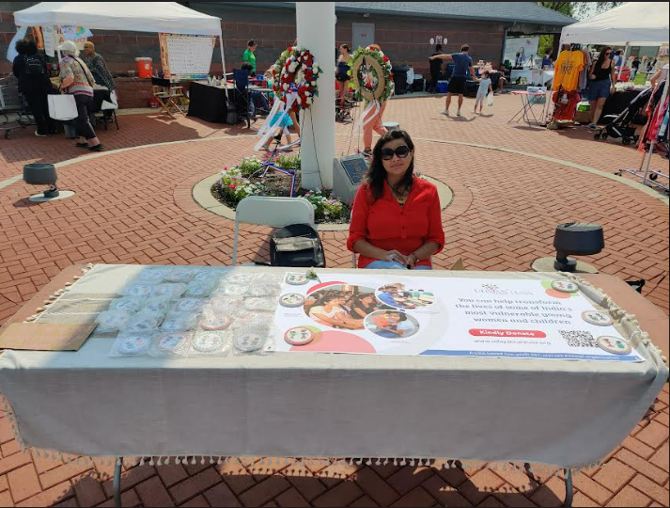

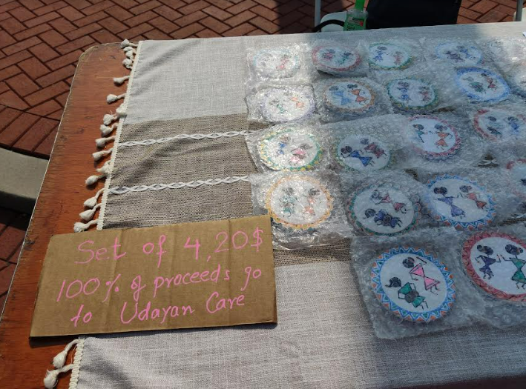

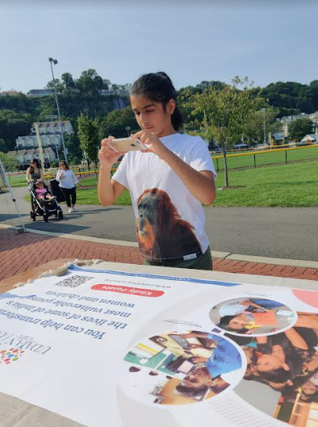

------------------------------end of report-------------------------------

